**DAILY ONLINE ACTIVITIES SUMMARY**

|  |  |  |  |  |  |  |  |
| --- | --- | --- | --- | --- | --- | --- | --- |
| **Date:** | **06-06-2020** | | | | **Name:** | **Vandana EV** | |
| **Sem& Sec** | **8thsemA sec** | | | | **USN:** | **4AL15CS103** | |
| **Online Test Summary** | | | | | | | |
| **Subject** | | **IOT** | | | | | |
| **Max. Marks** | | **30** | | **Score** | | **30** | |
| **Certification Course Summary** | | | | | | | |
| **Course** | **Introduction to Hadoop** | | | | | | |
| **Certificate Provider** | | | **Great learning Academy** | **Duration** | | | **4hrs** |
| **Coding Challenges** | | | | | | | |
| **Problem Statement-**:**1)** Python program for **given a two list. Create a third list by picking an odd-index element from the first list and even index elements from second.** | | | | | | | |
| **Status: completed** | | | | | | | |
| **Uploaded the report in Github** | | | | **yes** | | | |
| **If yes Repository name** | | | | **Vandana** | | | |
| **Uploaded the report in slack** | | | | **yes** | | | |

Online Test Details :

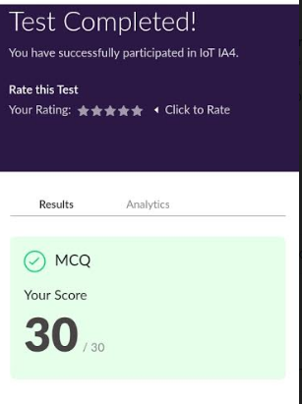

Certification Course Details :

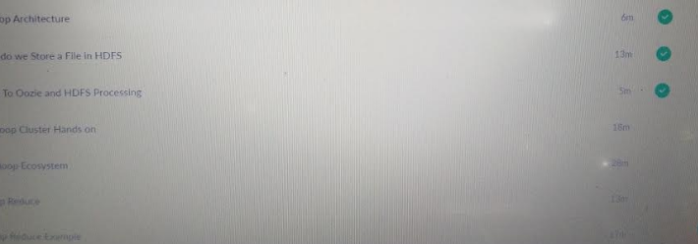

Coding Challenges Details:

listOne=[3,6,9,12,15,18,21]

listTwo=[4,8,12,16,20,24,28]

listThree=list()

oddElements=listOne[1::2]

print("Element at odd-index positions from list one")

print(oddElements)

EvenElement=listTwo[0::2]

print("Element at even-index positions from list two")

print(EvenElement)

print("Printing Final third list")

listThree.extend(oddElements)

listThree.extend(EvenElement)

print(listThree)